Office National Statistics
UK Retail Footfall (Regional)
Quarterly Analysis Report (Version 1.0)
Retail footfall is estimated using anonymised mobile-network data from BT Active Intelligence.
It is based on:
- Mobile activity: Detecting devices visiting designated retail areas.
- Location: Town centres, high streets and retail parks.
- Visitor identification: Excluding people who live within those retail areas.
- Population weighting: Adjusting estimates to improve regional representativeness.
Figure (0.1) Quarterly Retail Footfall Index (NE v Scotland)
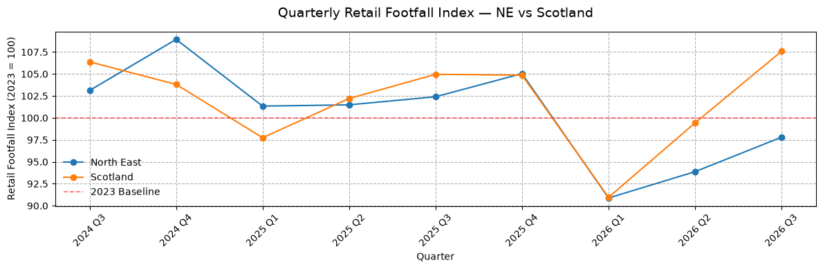
- Both observed Q1 periods in 2025 show weaker retail footfall compared with the preceding 2024 Q4, suggesting a much weaker post-Christmas seasonal slowdown.
- North East outperformed Scotland in Q1 2025 by 3.6 index points, while both regions recorded almost identical performance in Q1 2026.
Figure (0.2) Quarterly Retail Footfall Index Divergence (Scotland v NE)
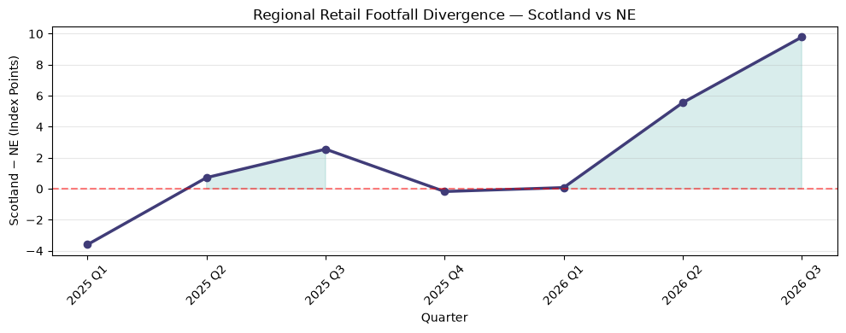
- Widening Regional Gap: Scotland's advantage increased from 0.08 index points in Q1 2026 to 9.78 in Q3 2026, representing a widening of 9.70 points.
- Scotland's Stronger Recovery: Both regions experienced a sharp decline in Q1 2026. However, Scotland recovered considerably faster, creating a progressively wider gap through Q2 and Q3.
- Throughout 2025, the regional gap fluctuated between −3.60 and +2.55 index points. By Q3 2026, Scotland's advantage reached +9.78 points, substantially exceeding the differences observed in 2025.
- YoY Growth Divergence: In Q3 2026, Scotland recorded +2.50% YoY growth, compared with −4.50% for the North East, representing a 7.00 percentage-point growth advantage for Scotland.
Increasingly divergent regional retail conditions suggest that Scotland and the North East should not be treated as directly equivalent markets without adjusting for underlying market trends.
Testing Implications
Scotland's retail footfall recovery has significantly outpaced North East England in 2026, with the regional index gap widening to 9.78 points by Q3. This growing divergence highlights the importance of accounting for regional market conditions when evaluating advertising campaign performance, particularly when using the North East as a test market and Scotland as a control.
Report (Version 2.0)
- Integrate other regional markets to get a more robust view.

Office National Statistics
Revolut UK Consumer Spend (Proxy)
Quarterly Analysis Report (Version 1.0)
The Spending on Revolut Debit Cards, is an ONS dataset using Revolut debit card transactions to track changes in UK consumer spending. This dataset measures how spending by Revolut account holder’s changes over time. It does not measure total UK consumer spending in pounds, and it does not directly measure how many goods people purchase. Betting expenditure is explicitly excluded because the ONS states that it can make entertainment spending too volatile.
Revolut Spending Data Categories
Category | Examples Included
Entertainment | Cinema, sporting events, ticketed events, gaming, streaming
Groceries | Supermarkets, convenience stores, grocery shops
Health | Pharmacies, prescriptions, private healthcare
Restaurants | Restaurants, pubs, takeaways, nightclubs
Services | Education, insurance, internet providers, professional and household services
Shopping | Clothing, electronics, beauty, furniture
Travel | Airline tickets, hotels and travel services
Transport | Fuel, public transport, taxis, car rental
Utilities | Gas, electricity and water

Figure (0.3) Calculation Method:
- Index Period (Year 1): Calculate the average monthly spending index for the reference year (e.g., January–October 2025).
- Comparison Period (Year 2): Calculate the average monthly spending index for the following year (e.g., January–October 2026).
- YoY Percentage Change: Calculate the percentage difference between the two period averages.

Figure (0.3) Revolut Total Spending Index (Year on Year Comparison)
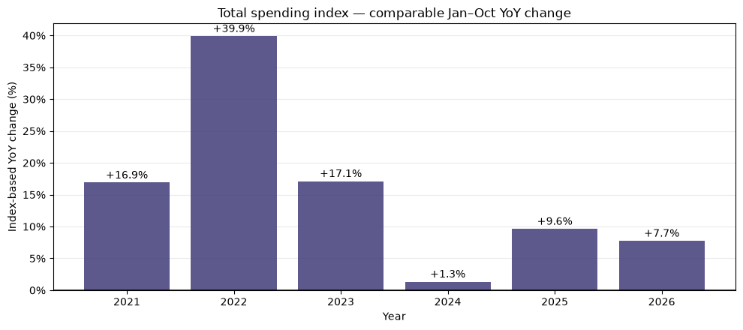
UK Consumer Spend Proxy Insights
- 2021–2022 — Exceptional Growth: YoY growth peaked at +39.9% in 2022, likely influenced by post-pandemic recovery, inflation and changing consumer behaviour.
- 2023–2024 — Significant Slowdown: Growth declined from +17.1% to +1.3%, indicating a substantial moderation in spending momentum.
- 2025 — Spending Recovery: Growth rebounded to +9.6%, suggesting renewed strength in consumer spending activity.
- 2026 — Continued Growth: Spending increased +7.7% YoY (YTD), indicating sustained positive growth, although below 2025 levels.
Revolut spending indices indicate that consumer spending growth has remained positive since 2020, despite considerable fluctuations. Following the 2024 slowdown, spending momentum strengthened in 2025 and remained positive in 2026.
Figure (0.4) Quarterly Sector Spend by Index
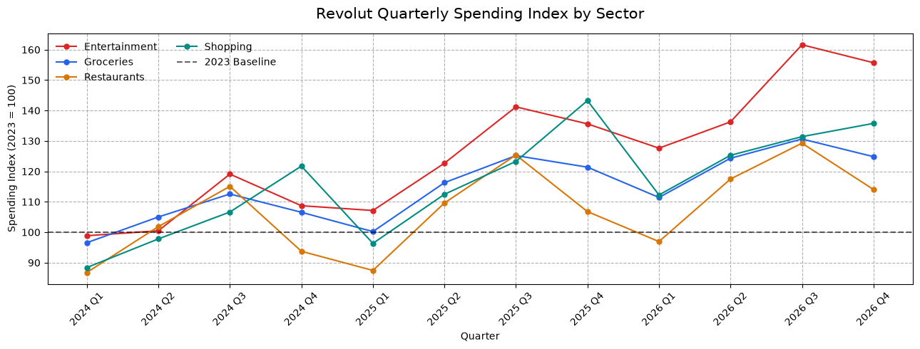Industry Insights
- Entertainment leads growth: The strongest-performing sector, reaching an index of 161.61 in Q3 2026, representing 61.6% above the 2023 baseline.
- Shopping shows sustained growth: Increased from 88.39 in Q1 2024 to 135.77 in Q4 2026, suggesting stronger nominal spending activity over the period.
- Groceries remain relatively stable: Recorded more gradual growth, reaching 130.63 in Q3 2026, with less volatility than Entertainment and Shopping.
- Restaurants demonstrate greater volatility: Spending fluctuates considerably, including a decline below the 2023 baseline in Q1 2026 (96.93), followed by recovery to 129.26 in Q3.
- Q3 consistently performs strongly: All four sectors show elevated spending indices during Q3, suggesting a recurring seasonal pattern.
Revolut spending indices indicate continued growth in nominal consumer spending activity across all four sectors, with Entertainment demonstrating the strongest performance. Q3 2026 recorded particularly elevated spending levels, while Groceries showed comparatively stable growth and Restaurants remained more volatile. These trends suggest varying sector-level consumer spending conditions that should be considered when benchmarking media campaign effectiveness
Methodological Considerations: Revolut spending data is not seasonally or inflation-adjusted and may not fully represent UK consumer behaviour. Indices are relative to the 2023 annual baseline (100), not actual expenditure. Additionally, Q4 2026 contains only October data, so it should not be directly compared with complete quarters.
Report (Version 2.0)
- Append new weekly data insights

